These instructions are guidance information within the body of the template.
DO NOT MODIFY STYLES.
- Blue text is sample and / or optional text. Select the appropriate value or remove.
- Red text is instructional. Delete or replace all red text in final version. Use the Paragraph (¶) button in the Toolbar to toggle on/off the red instructional text in this template.
- Black text is required and must be addressed in the template. All text must be black in the final version.
This System Architectural Design and Configuration Item Inventory (CII) template is intended to be utilized to document the architecture, and if applicable, the configuration item inventory, of a new system or major release. The template content may be tailored, (i.e., expanded or deleted) to address the needs of the project. This document is unique to a computer system and therefore, none will look alike or even have all the same sections. It is the responsibility of the technical team to define relevant content to support the system.
This template may be supported by the Software Detailed Design Description template (BTSQC09.05-O), and/or the Software Database Design Description template (BTSQC09.05-N), and/or the Software Interface Design Description template (BTSQC09.05-P), as applicable.
Per BTSQC09.05,this Architectural Design and Configuration Item Inventory template applies as follows:
System Classification | System Type
 | COTS | Config. | Custom
Quality Critical &  Quality Non-Critical Systems | Required, except CII section is Not Required | Required | Required
Regulated (Non-Quality) Systems | Optional | Required, except CII section is Not Required | Required, except CII section is Not Required
As a reminder, this template also applies for all Regulated (Quality or Non-Quality) systems that utilize Software-as-a-Service (SaaS) hosting, following the table above based on the System Type.
Header Instructions:
The following information should appear on each page of the document (i.e., be included in the header of the document by replacing the template’s header.
- Application Name and Acronym – Enter the application name and acronym as documented within the Document Management System and Application Inventory.
- Application Inventory ID – Enter the ID from the Application Inventory
- Document ID: Enter the document identifier for easy retrieval from the VMS tool.
- M-Files: Document Collection ID
- WindChill: Document ID
- Document Version: Enter the version number of this document.
- Document Name: Provide the name of the document.
Template Instructions End
Use the Paragraph (¶) button in the Toolbar to toggle on/off the red instructional text in this template.

System Architectural Design and Configuration Item Inventory (CII)
By approving this document, you attest that you have completed training on BTSQC09.05 and agree with the for this system.
Document Prepared by:

Name and Function | Signature | Date (DD-MON-YYYY)
Author | Captured electronically | Captured electronically

Document Approvals:
Name and Function | Signature | Date (DD-MON-YYYY)
Technical Architect | Captured electronically | Captured electronically
SME Title / SME | Captured electronically | Captured electronically

Revision History:
Document Version # | Revision Date  (DD-MON-YYYY) | Author | Change Summary  (Reference section[s] changed)
1.0 |  |  | Initial writing – describes the system architectural design and, if applicable, the configuration item inventory

OVERVIEW

Table of Contents
1.0 OVERVIEW 5
1.1 Table of Contents 5
1.2 Purpose 5
1.3 Acronyms and Definitions 6
1.4 References 6
1.5 Roles and Responsibilities 6
2.0 SYSTEM CONTEXT 7
3.0 PROCESS MODEL 7
4.0 SYSTEM ARCHITECTURE 7
4.1 System Architecture 7
4.2 Software Architecture 8
4.3 Application Architecture 9
4.4 Data Architecture 10
4.5 Interface Architecture 11
5.0 SECURITY 11
6.0 CONFIGURATION ITEM INVENTORY (CII) 13
6.1 Configuration Management 13
7.0 PERFORMANCE 13
8.0 RESILIENCY 14
8.1 Availability 14
8.2 Backups 14
8.3 Restore Testing 15
8.4 Disaster Recovery 15
9.0 APPENDICES 15
9.1 Appendix A CII Item Details 15
10.0 ATTACHMENTS 15
10.1 Attachment 1 CII Item Details 15

Purpose
This document describes the system architecture and high-level configuration and designconfiguration and designconfiguration and design parameters intended to satisfy the system’s functional behaviors, which support the business needs for the <Computer System Name>, to support Abbott < division > deployment.
The primary purpose of this document is to:
- Decompose the application into components / subsystems
- Identify each component via the configuration item, as applicable
- Describe how these components interact with each other
The specifications contained in this document are written from a developer’s perspective and it is used to support the system through its lifecycle.
This document is created in compliance with and under the guidance of procedure BTSQC09.05, Computer Systems Lifecycle and Validation.

Acronyms and Definitions

Click this link to access the Abbott Glossary.
Term / Acronym | Definition

References

Document Number | Document Title

Roles and Responsibilities

Function | Responsibility
Technical Architect | - Review and approval of the document
IT – Technical Team | - Document business process models, system architecture aspects including cybersecurity, data flows, configuration items if applicable, failover/disaster recovery mechanisms, and performance considerations, and update as needed as part of each release / upgrade

SYSTEM CONTEXT

The system context is shown below.

PROCESS MODEL

The process model is shown below.

SYSTEM ARCHITECTURE

System Architecture

The system architecture is based on standard hardware as described below and located in a server environment. Qualified in <data center> located in <location>. An overview is shown below.
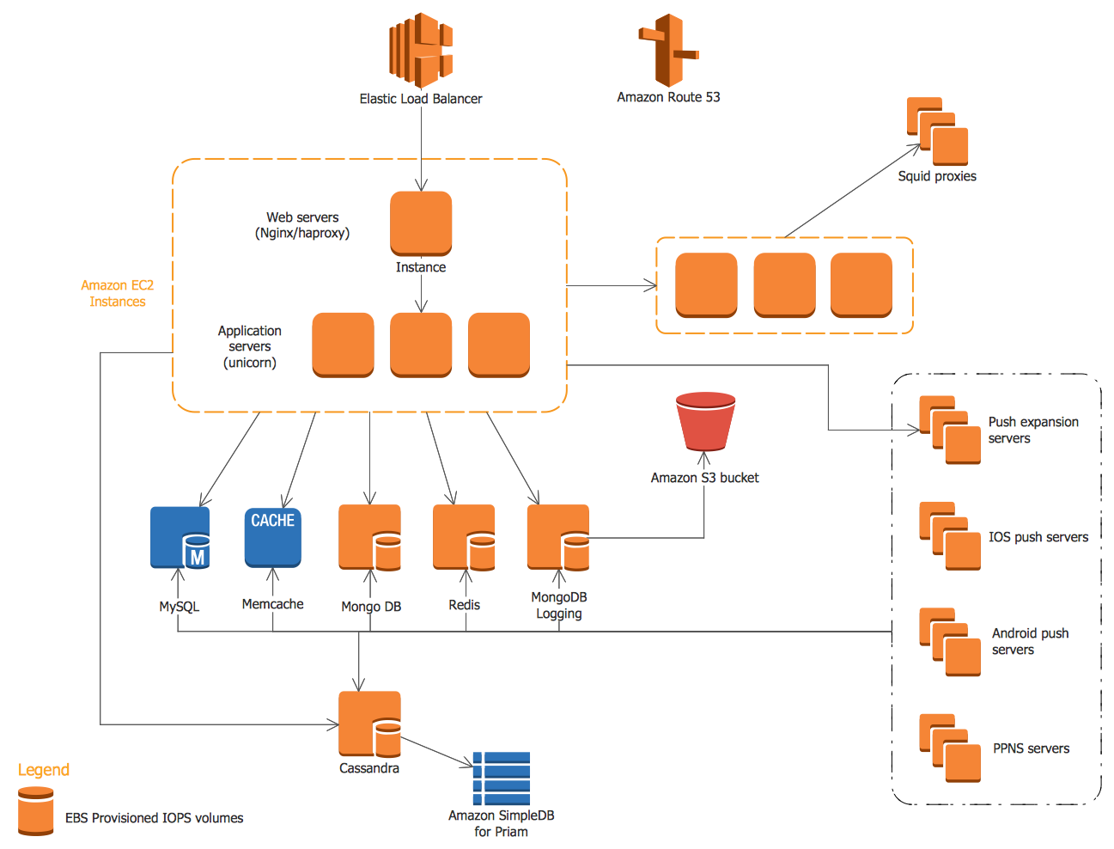
- System Architecture

Software Architecture

The Software Architecture attributes of the computer system are described below
Software | Release / Version | Library
Windows OS | 10.2.4.11

Application Architecture

The Application Architecture attributes of the computer system are described below
- QWP Computer System Software Application Architecture

Data Architecture

The Data Architecture attributes of the computer system are described below

Interface Architecture

The Interface Architecture attributes of the computer system are described below

SECURITY

The technical security and cybersecurity architecture aspects are described below at a high-level.
Design Elements | Design Considerations
Audit and Accountability
system and Communication Protection and Data Controls
Configuration and Architecture
Event Loggins and Incident Response
Security Assessment
Physical Security
System Hardening
Notifications

CONFIGURATION ITEM INVENTORY (CII)

Item | Description | Type | Version | System Identifier

Configuration Management

Justification of CMD Difference Between Test / QA and Production

PERFORMANCE

The table below identifies performance specifications.
Performance Parameter | Details
Capacity / Volume
Performance
Capacity
Reliability

RESILIENCY

Availability

Availability Consideration | Details / Comments

Backups
Name | Backed-up Item | Backup Type | Frequency | Method
CSXXX | Database Server | Incremental | Real-time | Rubrik
 |  | Full | Daily
CSXXX

Restore Testing
Restore Testing Strategy | Environment | Frequency
Restore Hidden table “XYZ.” | Production | Annual

Disaster Recovery

Disaster Recovery Steps | Responsible | Actions
DR Plan # | 1234567
Perform regular system backups. | IT Infrastructure | - RPO set to 4 hours  - RTO set to 2 hours
Declare a disaster | System Owner | Send email to all users.

APPENDICES

Appendix A CII Item Details

ATTACHMENTS

Attachment 1 CII Item Details

END OF DOCUMENT

